Datasets folder structure:

-CASIA2
--AU-Image Data
--CASIA 2 Groundtruth-Image Data
--Tp-Image Data
-CG1050
--TRAINING_CG-1050--Image Data
--VALIDATION_CG-1050-Image Data
-CIFAKE
--test-
---REAL-Image Data
---FAKE-Image Data
--train
---REAL-Image Data
---FAKE-Image Data
-CoMoFoD_small_v2-Image Data
-DETECTAIVSHUMAN
--test
---fake--Image Data
---real-Image Data
--train
---fake-Image Data
---real-Image Data

- Verified Human Text Datasets (For Stylometry & Burstiness)

-bookcorpus dataset link:
from datasets import load_dataset

ds = load_dataset("rojagtap/bookcorpus")

-emozilla dataset link:
from datasets import load_dataset

ds = load_dataset("emozilla/pg19")

-wikitext dataset links:
--from datasets import load_dataset

ds = load_dataset("Salesforce/wikitext", "wikitext-103-raw-v1")

--from datasets import load_dataset

ds = load_dataset("Salesforce/wikitext", "wikitext-103-v1")

--from datasets import load_dataset

ds = load_dataset("Salesforce/wikitext", "wikitext-2-raw-v1")

-reddit-title-body dataset link:
from datasets import load_dataset

ds = load_dataset("sentence-transformers/reddit-title-body")

2. AI vs. Human Contrastive Datasets (For Proxy Detectors)
--HC3 (Human ChatGPT Comparison Corpus):

-from datasets import load_dataset

ds = load_dataset("Hello-SimpleAI/HC3", "all")

-from datasets import load_dataset

ds = load_dataset("Hello-SimpleAI/HC3", "finance")

-from datasets import load_dataset

ds = load_dataset("Hello-SimpleAI/HC3", "medicine")

-ArguGPT:
-from datasets import load_dataset

ds = load_dataset("SJTU-CL/ArguGPT")

APT (Adversarial Paraphrasing Task):
from datasets import load_dataset

ds = load_dataset("tasksource/apt")

Instruction Fine-Tuning & Rewriting (For Model Calibration)

PAWS (Paraphrase Adversaries from Word Scrambling):
-from datasets import load_dataset

# Login using e.g. `huggingface-cli login` to access this dataset
ds = load_dataset("hgissbkh/paws-x")

The FLAN Collection:

FLAN-main
This dataset directory folderwise structure
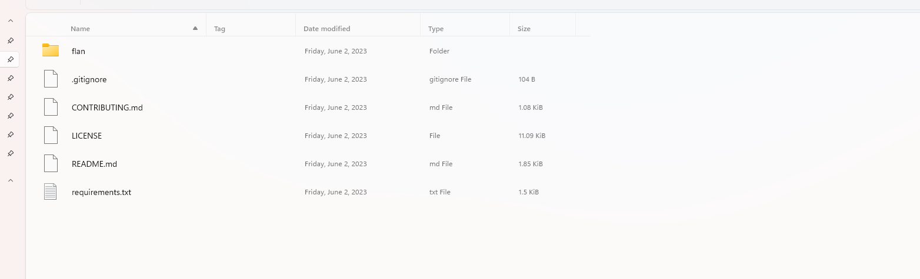
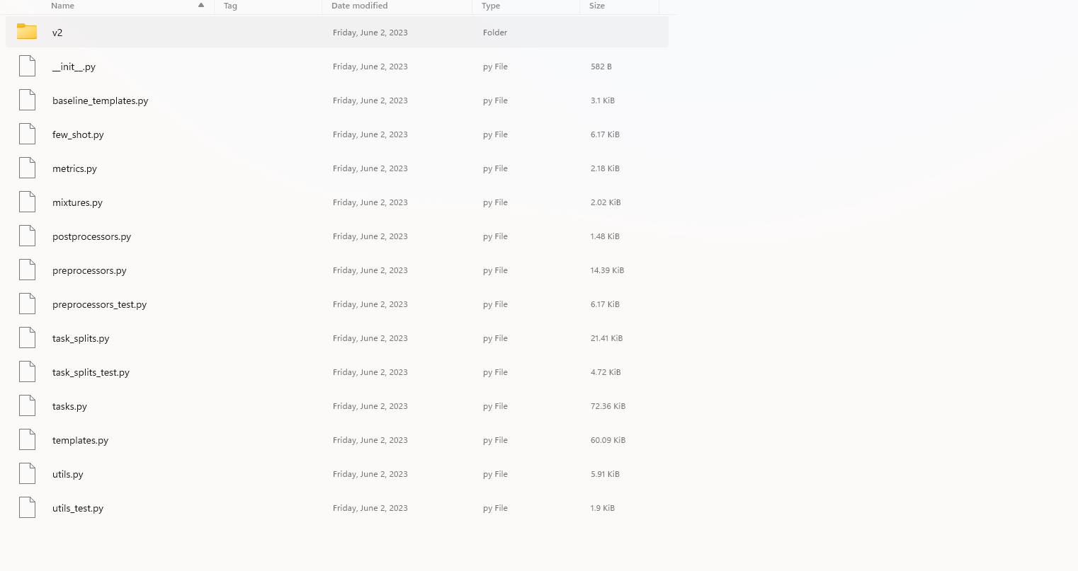
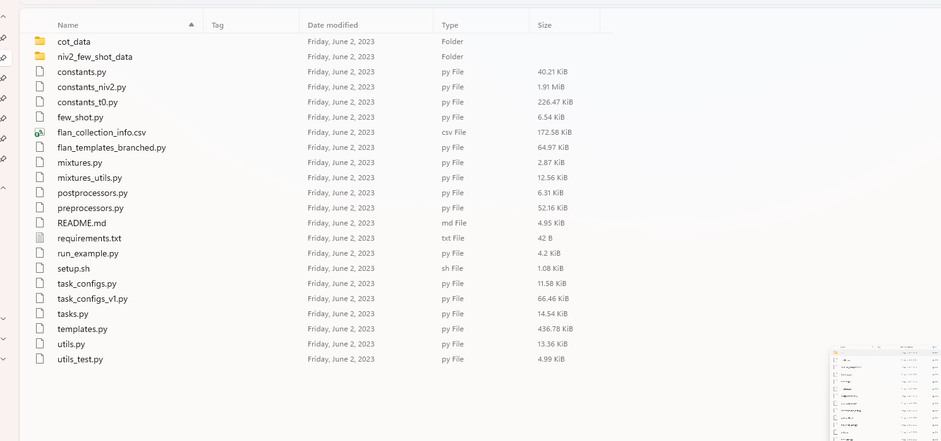
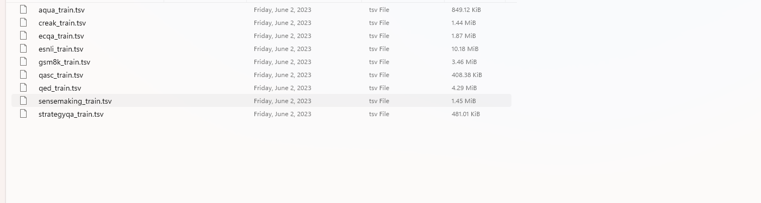
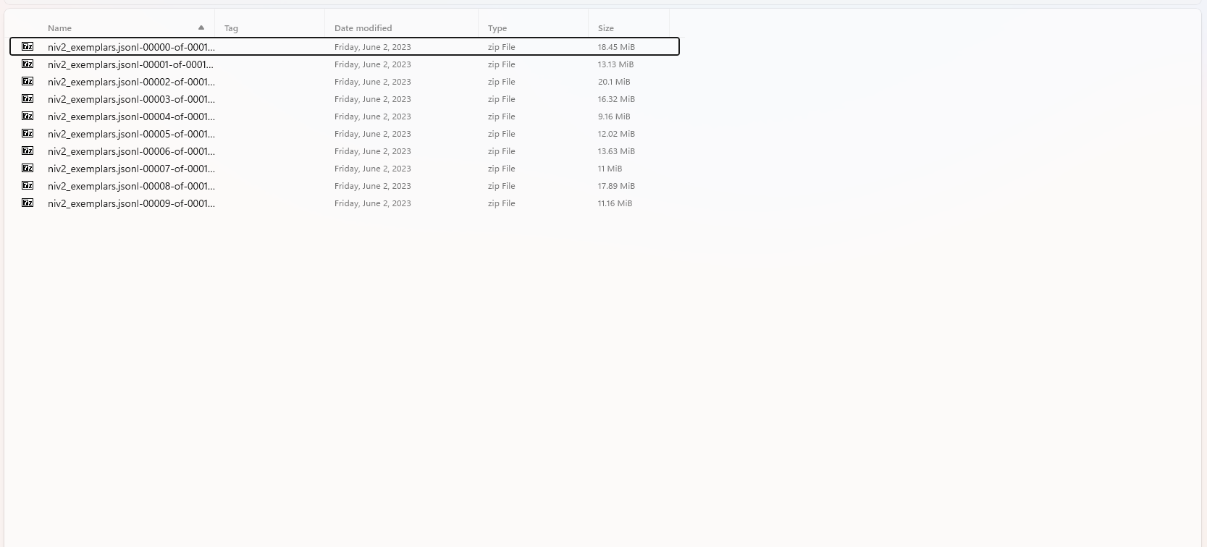

.gitnore
CONTRIBUTING.md
LICENSE
README.md
requirements

Alpaca:
from datasets import load_dataset

ds = load_dataset("tatsu-lab/alpaca")

Dolly:
from datasets import load_dataset

ds = load_dataset("databricks/databricks-dolly-15k")

Adversarial Edge-Case & Sanitization Datasets (For QA & CI/CD):
RealToxicityPrompts:
from datasets import load_dataset

ds = load_dataset("allenai/real-toxicity-prompts")

